**INDEX**

|  |  |  |
| --- | --- | --- |
| **S. No** | **PROGRAMS LIST** | **Page No.** |
| 1 | Program for linear search. | 4-5 |
| 2 | Program for Bubble sort . | 6-7 |
| 3 | Program for Selection sort. | 8-9 |
| 4 | Program for Insertion sort . | 10-11 |
| 5 | Program for Binary Search . | 12-13 |
| 6 | Program for Binary Search using recursion . | 14-15 |
| 7 | Program for Tower of Hanoi . | 16-17 |
| 8 | Program for Quick sort . | 18-19 |
| 9 | Program for Merge sort . | 20-22 |
| 10 | Program for Counting sort . | 23-24 |
| 11 | Program for Radix sort . | 25-26 |
| 12 | Program for fractional Knapsack problem using greedy method . | 27-29 |
| 13 | Program for Shell sort . | 30-31 |
| 14 | Program for Heap sort . | 32-33 |
| 15 | Program for Tree sort . | 34-36 |
| 16 | Program for Longest common subsequence . | 37-39 |
| 17 | Program for Matrix chain multiplication . | 40-42 |
| 18 | Program for Floyd Warshall all pair shortest path . | 43-44 |
| 19 | Program for strassean matrix multiplication . | 45-46 |
| 20 | Program for Dijkstra algorithm . | 47-49 |
| 21 | Program for 0/1 knapsack problem by dynamic programming . | 50-52 |
| 22 | Program for Graph Traversal using BFS . | 53-55 |
| 23 | Program for Graph Traversal using DFS . | 56-57 |
| 24 | Program for N Queen’s Problem . | 58-60 |
| 25 | Program for MST using prim’s algorithm . | 61-64 |
| 26 | Program for MST using kruskal algorithm. | 65-67 |
| 27 | Program for Sum of subset problem. | 68-69 |
| 28 | Program for Graph coloring problem. | 70-72 |
| 29 | Program for Job scheduling with deadline problem. | 73-76 |
| 30 | Program for Vertex cover problem using approximation algorithm. | 77-79 |
|  |  |  |

**Ques – 1:- Program for linear search.**

**Code :-**

#include <stdio.h>

#include<conio.h>

void main()

{

clrscr();

int a[50],search,i,n;

printf("Enter number of elements in array\n");

scanf("%d",&n);

printf("Enter %d integer(s)\n", n);

for (i=0;i<n;i++)

scanf("%d",&a[i]);

printf("Enter a number to search\n");

scanf("%d",&search);

for (i=0;i<n;i++)

{

if (a[i] == search)

{

printf("%d is present at location %d.\n", search, i+1);

break;

}

}

if (i == n)

printf("%d isn't present in the array.\n", search);

getch();

}

**Output is :-**

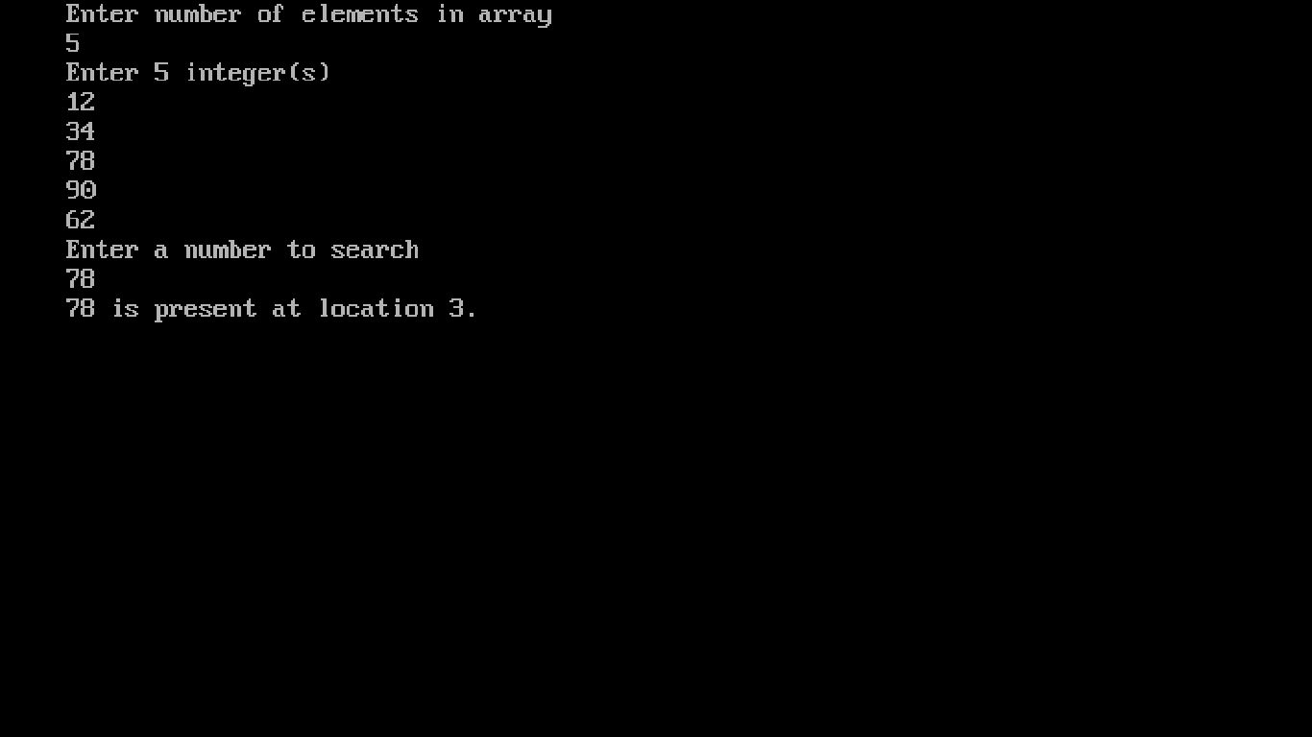

**Ques 2:- Program for Bubble sort .**

**Code :-**

#include <stdio.h>

#include <conio.h>

void main()

{

clrscr();

int array[100], n, i, j, swap;

printf("Enter number of elements\n");

scanf("%d", &n);

printf("Enter %d integers\n", n);

for (i=0;i<n;i++)

scanf("%d", &array[i]);

for (i=0;i<n-1;i++)

{

for (j=0;j<n-i-1;j++)

{

if (array[j]>array[j+1])

{

swap = array[j];

array[j] = array[j+1];

array[j+1] = swap;

}

}

}

printf("Sorted list in ascending order:\n");

for (i=0;i<n;i++)

printf("%d\n", array[i]);

getch();

}

**Output is :-**

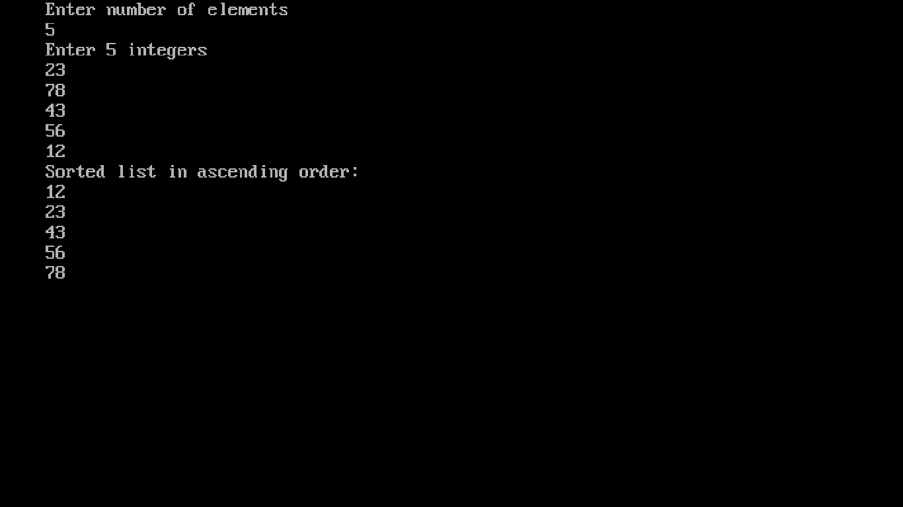

**Ques 3:- Program for Selection sort .**

**Code :-**

#include <stdio.h>

#include <conio.h>

void main()

{

clrscr();

int array[100], n, i, j, p, t;

printf("Enter number of elements\n");

scanf("%d", &n);

printf("Enter %d integers\n", n);

for (i=0;i<n;i++)

scanf("%d", &array[i]);

for (i=0;i<(n-1);i++)

{

p=i;

for (j=i+1;j<n;j++)

{

if (array[p]>array[j])

p=j;

}

if (p!=i)

{

t = array[i];

array[i] = array[p];

array[p] = t;

}

}

printf("Sorted list in ascending order:\n");

for (i=0;i<n;i++)

printf("%d\n", array[i]);

getch();

}

**Output is :-**

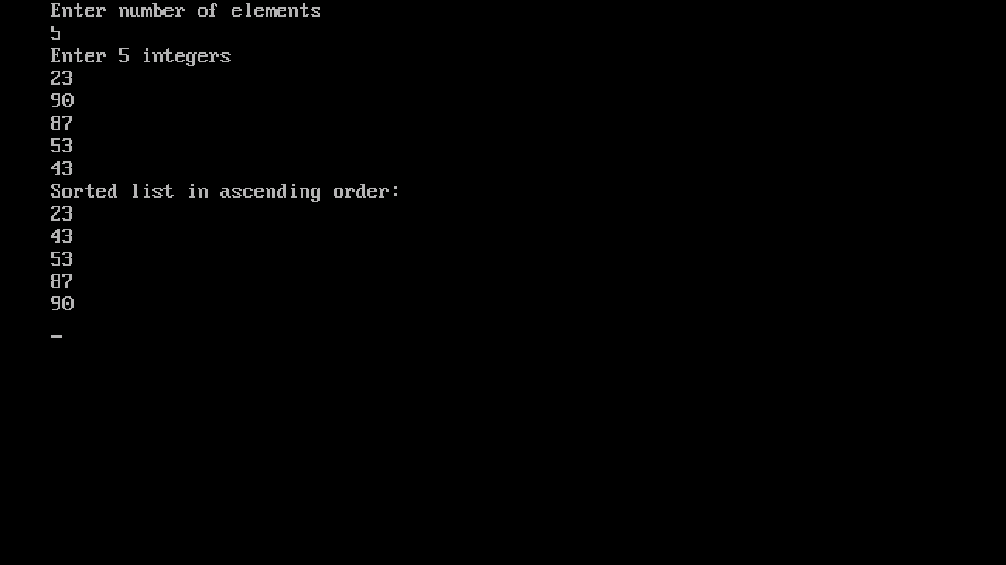

**Ques 4 :- Program for Insertion sort .**

**Code :-**

#include<stdio.h>

#include<conio.h>

void main()

{

clrscr();

int n,array[100],i,j,k,temp=0;

printf("Enter number of elements\n");

scanf("%d", &n);

printf("Enter %d integers\n", n);

for (i=0;i<n;i++)

scanf("%d", &array[i]);

for (i=1;i<=n-1;i++)

{

k = array[i];

for (j=i-1;j>=0;j--)

{

if (array[j]>k)

{

array[j+1]=array[j];

temp=1;

}

else

break;

}

if (temp)

array[j+1] = k;

}

printf("Sorted list is:\n");

for (i=0;i<=n-1;i++)

{

printf("%d\n", array[i]);

}

getch();

}

**Output is :-**

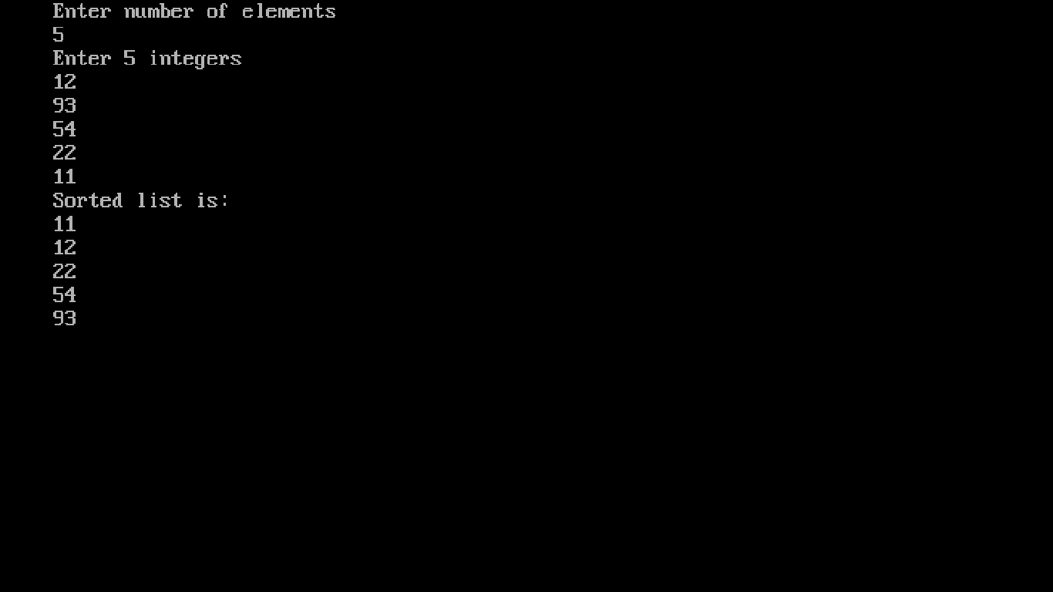

**Ques 5:- Program for Binary Search .**

**Code :-**

#include<stdio.h>

#include<conio.h>

void main()

{

clrscr();

int n,i, first, last, middle, search, array[1000];

printf("Enter number of elements\n");

scanf("%d",&n);

printf("Enter %d integers\n", n);

for (i=0;i<n;i++)

scanf("%d",&array[i]);

printf("Enter value to find\n");

scanf("%d",&search);

first = 0;

last = n - 1;

middle = (first+last)/2;

while (first <= last)

{

if (array[middle] < search)

first = middle + 1;

else if (array[middle] == search)

{

printf("%d found at location %d.\n", search, middle+1);

break;

}

else

last = middle - 1;

middle = (first + last)/2;

}

if (first > last)

printf("Not found! %d isn't present in the list.\n", search);

getch();

}

**Output is :-**

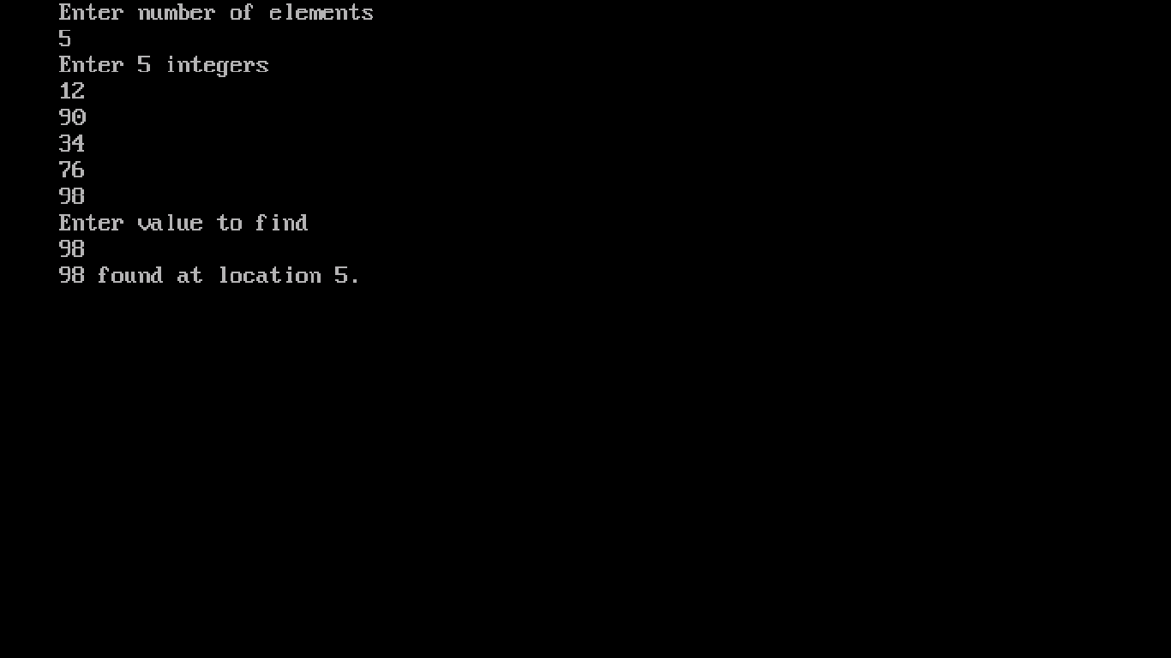

**Ques 6:- Program for Binary Search using recursion .**

**Code:-**

#include<stdio.h>

#include<conio.h>

#include<stdlib.h>

#define size 10

int binsearch(int[], int, int, int);

int main()

{

clrscr();

int num, i, key, position;

int low, high, list[size];

printf("\nEnter the total number of elements");

scanf("%d", &num);

printf("\nEnter the elements of list :");

for (i = 0; i < num; i++) {

scanf("%d", &list[i]);

}

low = 0;

high = num - 1;

printf("\nEnter element to be searched : ");

scanf("%d", &key);

position = binsearch(list, key, low, high);

if (position != -1)

{

printf("\nNumber present at %d", (position + 1));

} else

printf("\n The number is not present in the list");

return (0);

}

int binsearch(int a[], int x, int low, int high)

{

int mid;

if (low > high)

return -1;

mid = (low + high) / 2;

if (x == a[mid])

{

return (mid);

}

else

if (x < a[mid])

{

binsearch(a, x, low, mid - 1);

}

else

{

binsearch(a, x, mid + 1, high);

}

}

**Output is :-**

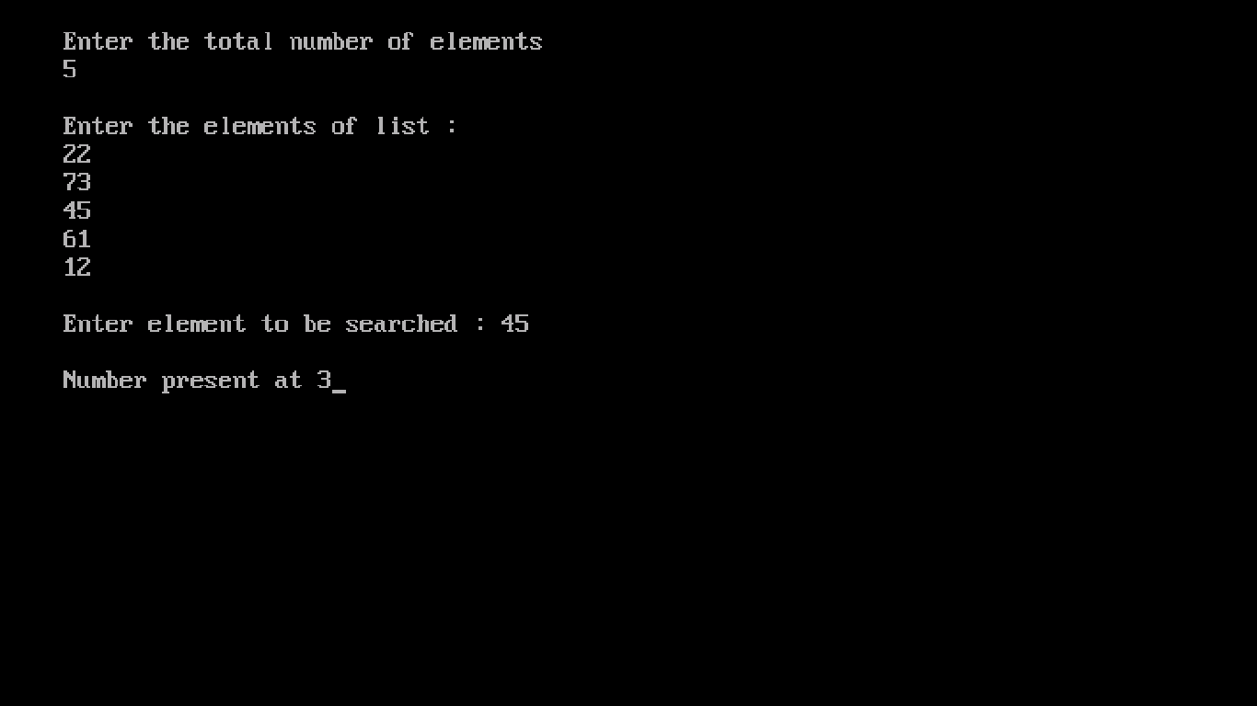

**Ques 7:- Program for Tower of Hanoi .**

**Code:-**

#include<stdio.h>

#include<conio.h>

void TOH(int, char, char, char);

int main ()

{

clrscr();

int n;

printf("Enter number of disks required: \n");

scanf ("%d", &n);

TOH (n, 'A', 'B', 'C');

getch();

return 0;

}

void TOH (int n, char src, char spare, char dest)

{

if (n==1)

printf("Move from %c to %c \n", src, dest);

else

{

TOH(n-1, src, dest, spare) ;

TOH(1, src, spare, dest);

TOH(n-1, spare, src, dest);

}

}

**Output is :-**

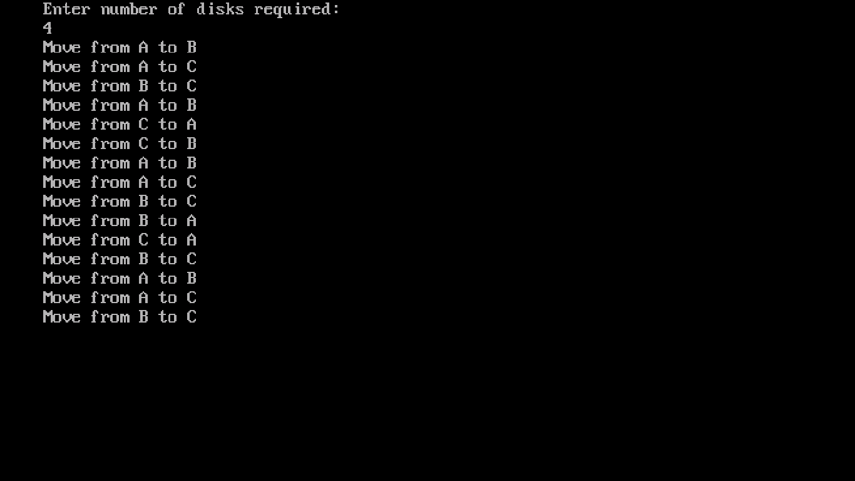

**Ques 8:- Program for Quick sort .**

**Code :-**

#include<stdio.h>

#include<conio.h>

void quicksort(int number[25],int first,int last)

{

int i, j, pivot, temp;

if(first<last)

{

pivot=first;

i=first;

j=last;

while(i<j)

{

while(number[i]<=number[pivot] && i<last)

i++;

while(number[j]>number[pivot])

j--;

if(i<j)

{

temp=number[i];

number[i]=number[j];

number[j]=temp;

}

}

temp=number[pivot];

number[pivot]=number[j];

number[j]=temp;

quicksort(number,first,j-1);

quicksort(number,j+1,last);

}

}

void main()

{

clrscr();

int i, count, number[25];

printf("How many elements are u going to enter?: ");

scanf("%d",&count);

printf("Enter %d elements: ", count);

for(i=0;i<count;i++)

scanf("%d",&number[i]);

quicksort(number,0,count-1);

printf("Order of Sorted elements: ");

for(i=0;i<count;i++)

printf(" %d",number[i]);

getch();

}

**Output is :-**

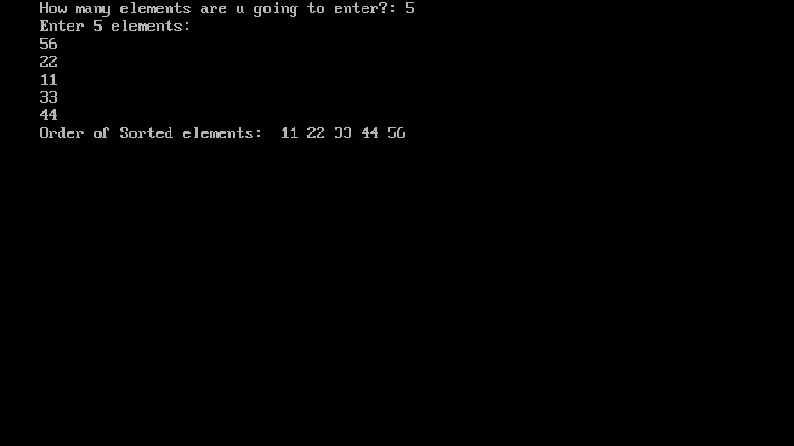

**Ques 9:- Program for Merge sort .**

**Code :-**

#include<stdio.h>

#include<conio.h>

#define MAX_SIZE 5

void merge_sort(int, int);

void merge_array(int, int, int, int);

int arr_sort[MAX_SIZE];

int main()

{

clrscr();

int i;

printf("\nEnter %d Elements for Sorting\n", MAX_SIZE);

for (i = 0; i < MAX_SIZE; i++)

scanf("%d", &arr_sort[i]);

printf("\nYour Data :");

for (i = 0; i < MAX_SIZE; i++)

{

printf("\t%d", arr_sort[i]);

}

merge_sort(0, MAX_SIZE - 1);

printf("\n\nSorted Data :");

for (i = 0; i < MAX_SIZE; i++)

{

printf("\t%d", arr_sort[i]);

}

getch();

}

void merge_sort(int i, int j)

{

int m;

if (i < j) {

m = (i + j) / 2;

merge_sort(i, m);

merge_sort(m + 1, j);

merge_array(i, m, m + 1, j);

}

}

void merge_array(int a, int b, int c, int d)

{

int t[50];

int i = a, j = c, k = 0;

while (i <= b && j <= d) {

if (arr_sort[i] < arr_sort[j])

t[k++] = arr_sort[i++];

else

t[k++] = arr_sort[j++];

}

while (i <= b)

t[k++] = arr_sort[i++];

while (j <= d)

t[k++] = arr_sort[j++];

for (i = a, j = 0; i <= d; i++, j++)

arr_sort[i] = t[j];

}

**Output is :-**

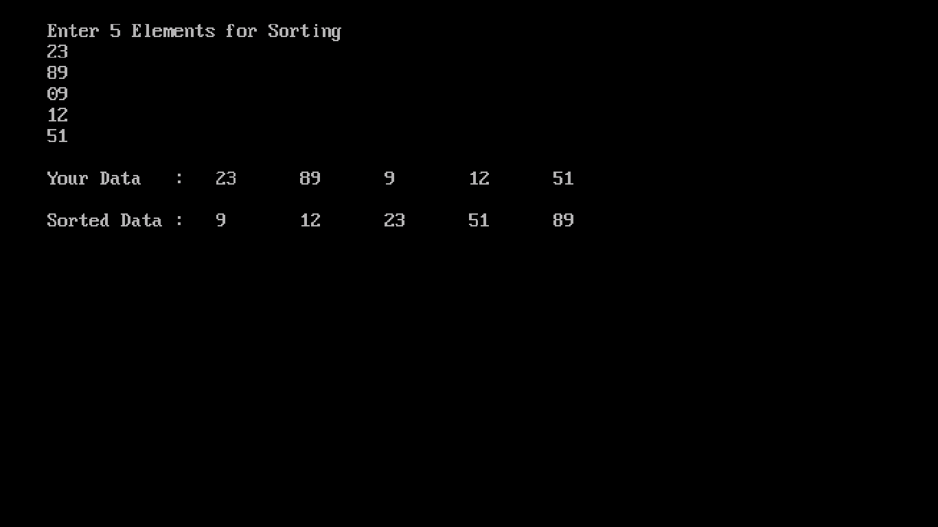

**Ques 10:- Program for Counting sort .**

**Code :-**

#include <stdio.h>

#include <conio.h>

void counting_sort(int A[],

int k, int n)

{

int i, j;

int B[15], C[100];

for (i = 0; i <= k; i++)

C[i] = 0;

for (j = 1; j <= n; j++)

C[A[j]] = C[A[j]] + 1;

for (i = 1; i <= k; i++)

C[i] = C[i] + C[i-1];

for (j = n; j >= 1; j--)

{

B[C[A[j]]] = A[j];

C[A[j]] = C[A[j]] - 1;

}

printf("The Sorted array

is : ");

for (i = 1; i <= n; i++)

printf("%d ", B[i]);

}

void main()

{

clrscr();

int n, k = 0, A[15], i;

printf("Enter the number

of input : ");

scanf("%d", &n);

printf("\nEnter the

elements to be sorted :\n");

for (i = 1; i <= n; i++)

{

scanf("%d", &A[i]);

if (A[i] > k) {

k = A[i];

}

}

counting_sort(A, k, n);

printf("\n");

getch();

}

**Output is :-**

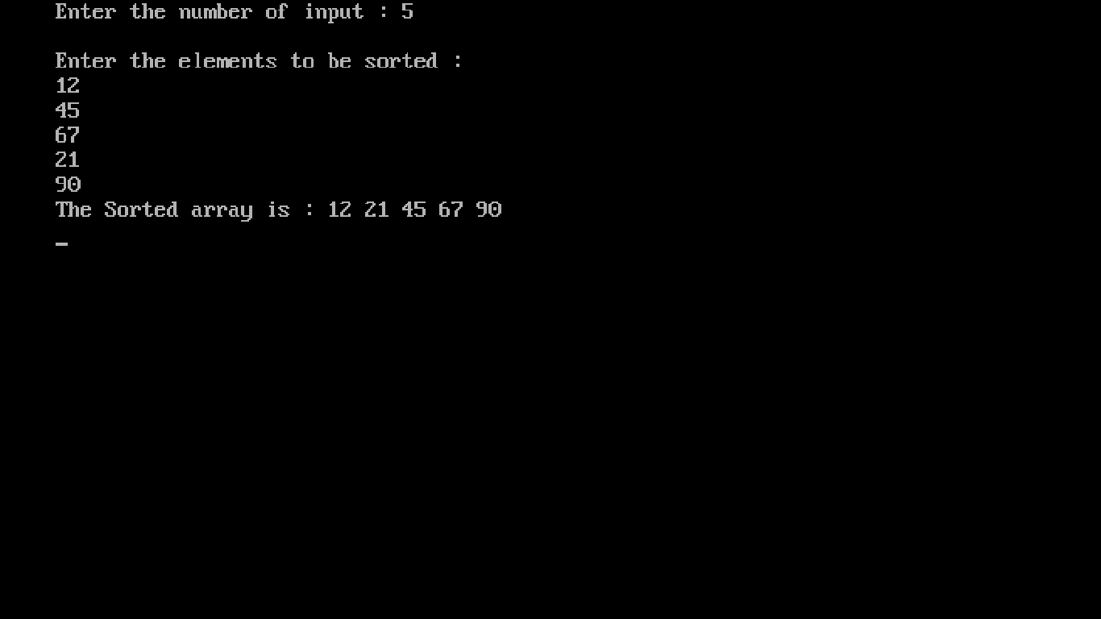

**Ques 11:- Program for Radix sort .   
Code :-**

#include <stdio.h>

#include <conio.h>

int print(int *a, int n)

{

int i;

for (i = 0; i < n; i++)

printf("%d\t", a[i]);

}

void radix_sort(int *a, int n)

{

int i, b[10], m = 0, exp = 1;

for (i = 0; i < n; i++)

{

if (a[i] > m)

m = a[i];

}

while (m / exp > 0)

{

int box[10] = { 0 };

for (i = 0; i < n; i++)

box[a[i] / exp % 10]++;

for (i = 1; i < 10; i++)

box[i] += box[i - 1];

for (i = n - 1; i >= 0; i--)

b[--box[a[i] / exp % 10]] = a[i];

for (i = 0; i < n; i++)

a[i] = b[i];

exp *= 10;

}

}

void main()

{

int arr[10];

int i, num;

clrscr();

printf("Enter Number of Elements:- ");

scanf("%d", &num);

printf("Enter %d Integers:- ", num);

for (i = 0; i < num; i++)

scanf("%d", &arr[i]);

radix_sort(&arr[0], num);

printf("Sorted list in ascending order by Radix sort :- \n ");

print(&arr[0], num);

getch();

}

**Output is :-**

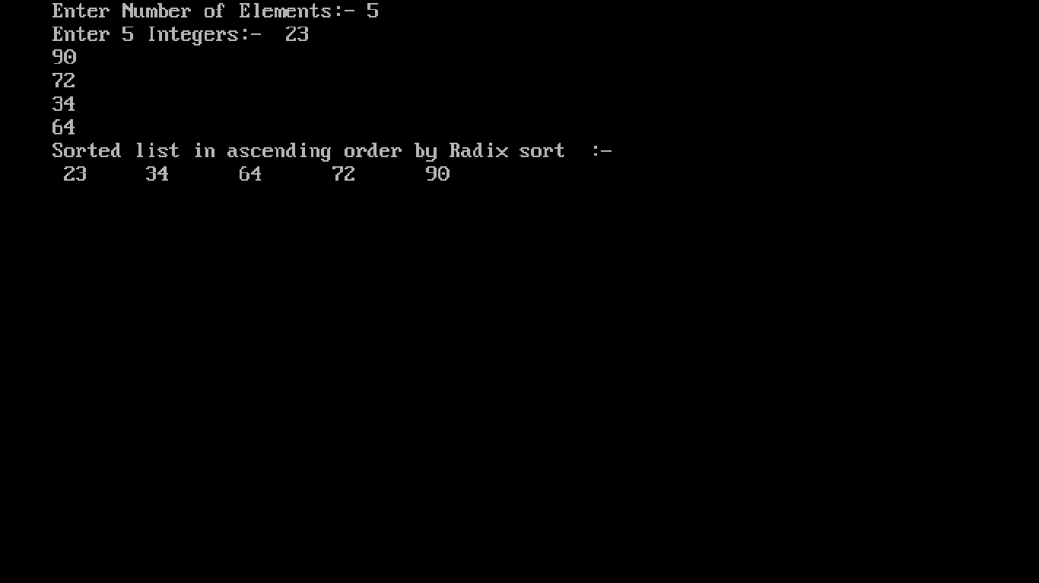

**Ques 12:- Program for fractional Knapsack problem using greedy method .**

**Code :-**

# include<stdio.h>

# include<conio.h>

void knapsack(int n, float weight[], float profit[], float capacity)

{

float x[20], tp = 0;

int i, j, u;

u = capacity;

for (i = 0; i < n; i++) x[i] = 0.0;

for (i = 0; i < n; i++)

{

if (weight[i] > u)

break;

else

{

x[i] = 1.0;

tp = tp + profit[i]; u = u - weight[i];

}

}

if (i < n)

x[i] = u / weight[i];

tp = tp + (x[i] * profit[i]);

printf("\nThe result vector is:- ");

for (i = 0; i < n; i++)

printf("%f\t", x[i]);

printf("\nMaximum profit is:- %f", tp);

}

void main()

{

clrscr();

float weight[20], profit[20], capacity; int num, i, j;

float ratio[20], temp;

printf("Enter the no. of objects \n :- ");

scanf("%d", &num);

printf("Enter the wts and profits of each object \n :- ");

for (i = 0; i < num; i++)

{

scanf("%f %f", &weight[i], &profit[i]);

}

printf("Enter the capacityacity of knapsack \n :- ");

scanf("%f", &capacity);

for (i = 0; i < num; i++)

{

ratio[i] = profit[i] / weight[i];

}

for (i = 0; i < num; i++)

{

for (j = i + 1; j < num; j++)

{

if (ratio[i] < ratio[j])

{

temp = ratio[j];

ratio[j] = ratio[i];

ratio[i] = temp;

temp = weight[j];

weight[j] = weight[i];

weight[i] = temp;

temp = profit[j];

profit[j] = profit[i];

profit[i] = temp;

}

}

}

knapsack(num, weight, profit, capacity);

getch();

}

**Output is :-**

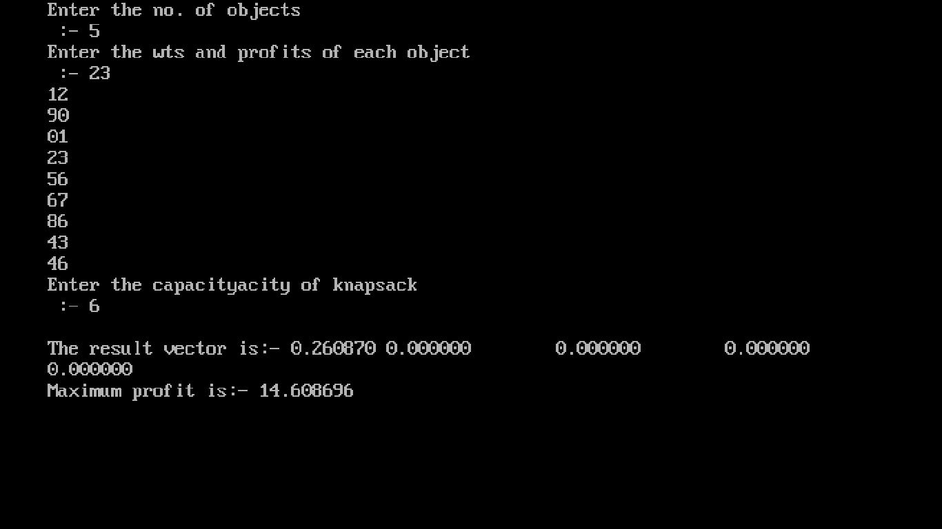

**Ques 13:- Program for Shell sort .**

**Code :-**

#include <stdio.h>

#include <conio.h>

void shellsort(int arr[], int num)

{

int i, j, k, tmp;

for (i = num / 2; i > 0; i = i / 2)

{

for (j = i; j < num; j++)

{

for(k = j - i; k >= 0; k = k - i)

{

if (arr[k+i] >= arr[k])

break;

else

{

tmp = arr[k];

arr[k] = arr[k+i];

arr[k+i] = tmp;

}

}

}

}

}

void main()

{

clrscr();

int arr[50];

int n, num;

printf(" \n Enter total no. of elements \n :- ");

scanf("%d", &num);

printf(" \n Enter %d numbers \n :- \n ", num);

for (n = 0 ; n < num; n++)

{

scanf("%d", &arr[n]);

}

shellsort(arr, num);

printf(" \n Sorted array is \n :- \n ");

for (n = 0; n < num; n++)

printf("%d ", arr[n]);

getch();

}

**Output is :-**

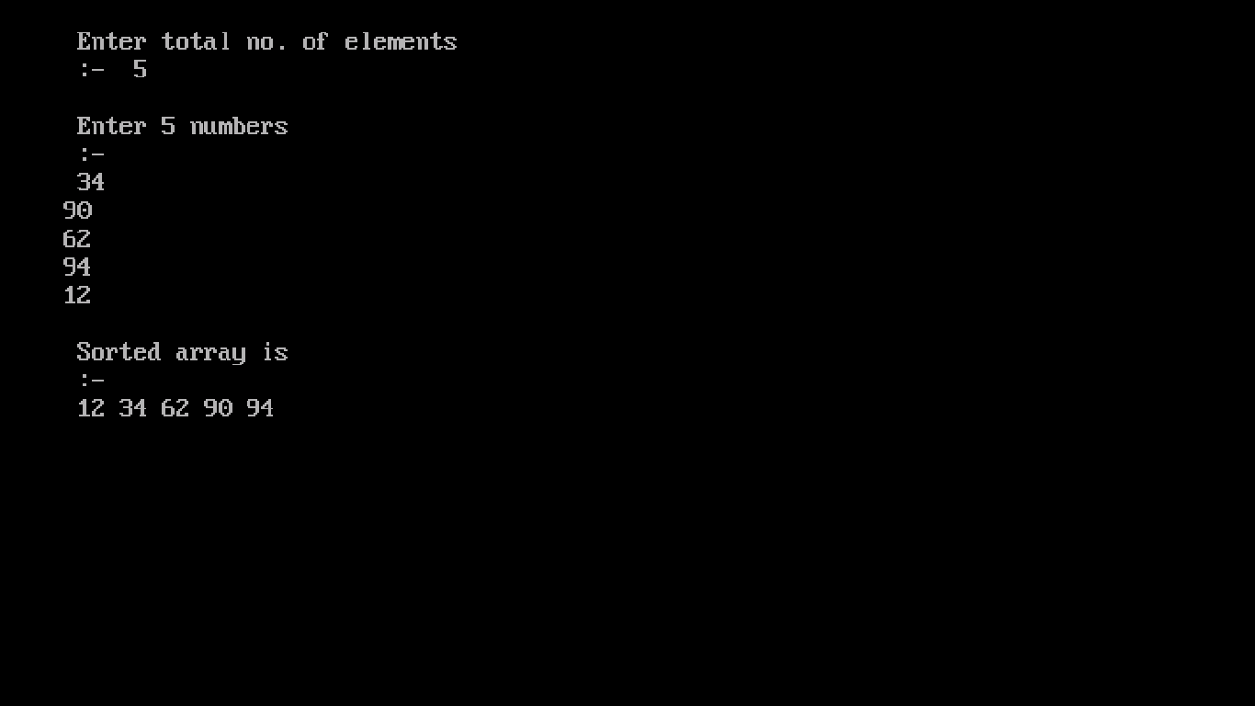

**Ques 14 :- Program for Heap sort .**

**Code :-**

#include<stdio.h>

#include<conio.h>

int temp;

void heapify(int arr[], int size, int i)

{

int largest = i;

int left = 2*i + 1;

int right = 2*i + 2;

if (left < size && arr[left] >arr[largest])

largest = left;

if (right < size && arr[right] > arr[largest])

largest = right;

if (largest != i)

{

temp = arr[i];

arr[i]= arr[largest];

arr[largest] = temp;

heapify(arr, size, largest);

}

}

void heapSort(int arr[], int size)

{

int i;

for (i = size / 2 - 1; i >= 0; i--)

heapify(arr, size, i);

for (i=size-1; i>=0; i--)

{

temp = arr[0];

arr[0]= arr[i];

arr[i] = temp;

heapify(arr, i, 0);

}

}

void main()

{

clrscr();

int arr[] = {1, 10, 2, 3, 4, 1, 2, 100,23, 2};

int i;

int size = sizeof(arr)/sizeof(arr[0]);

heapSort(arr, size);

printf("The Heapify sorted elements\n");

for (i=0; i<size; ++i)

printf("%d\n",arr[i]);

}

**Output is :-**

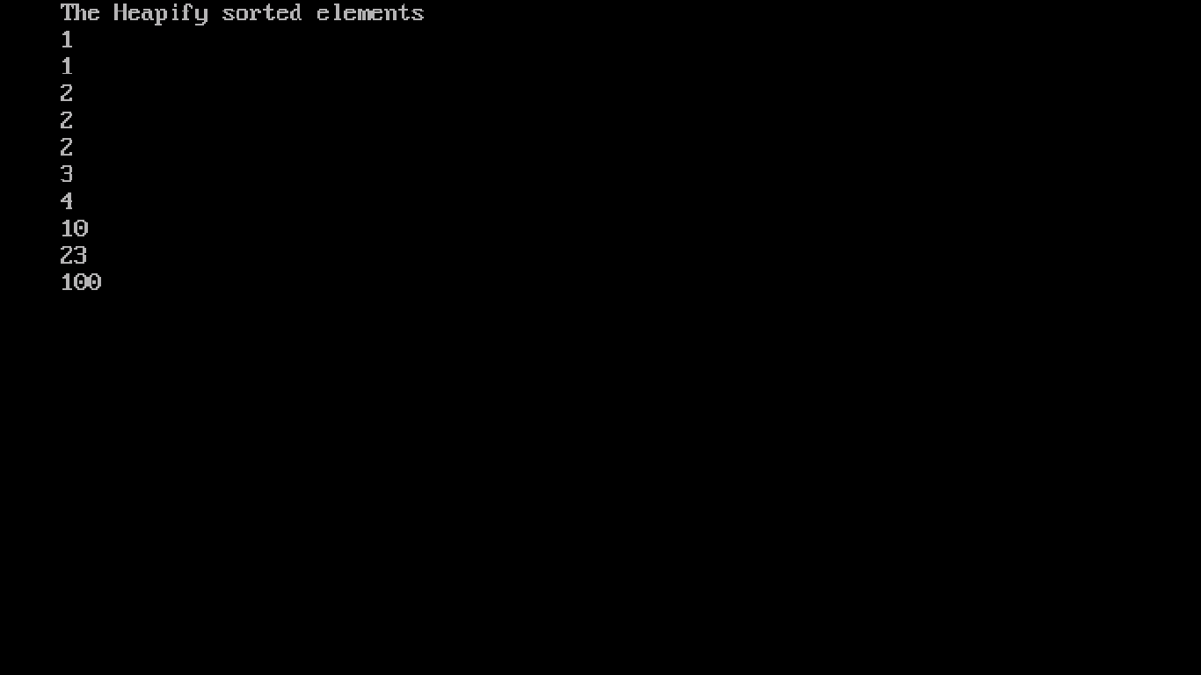

**Ques 15:- Program for Tree sort .**

**Code :-**

#include<stdio.h>

#include<conio.h>

#include<alloc.h>

struct node{

int info;

struct node *lp;

struct node *rp;

};

void inorder(int arr[], struct node* root)

{

if(root!=NULL)

{

static int i = 0;

inorder(arr,root->lp);

arr[i++]=root->info;

inorder(arr,root->rp);

}

}

void main()

{

clrscr();

int arr[10],n;

printf("Enter the size of array:- \n");

scanf("%d",&n);

printf("\nEnter %d array elements:- \n",n);

for(int i = 0; i<n; i++)

scanf("%d",&arr[i]);

struct node *head = (struct node *)malloc(sizeof(struct node));

struct node *ptr = (struct node *)malloc(sizeof(struct node));

ptr->info = arr[0];

ptr->lp = NULL;

ptr->rp = NULL;

head = ptr;

for(i = 1; i<n; i++)

{

ptr = head;

struct node *next = (struct node *)malloc(sizeof(struct node));

next->info = arr[i];

next->lp = NULL;

next->rp = NULL;

int flag;

do

{

flag = 0;

if((next->info)<(ptr->info))

{

if(ptr->lp==NULL)

{

ptr->lp = next;

flag = 1;

}

else

{

ptr = ptr->lp;

}

}

else

{

if(ptr->rp==NULL)

{

ptr->rp = next;

flag = 1;

}

else

{

ptr = ptr->rp;

}

}

}

while(flag==0);

}

inorder(arr,head);

printf("\n******************\n");

printf("\nSorted array:\n");

for(i = 0; i<n; i++)

printf("%d ",arr[i]);

getch();

}

**Output is :-**

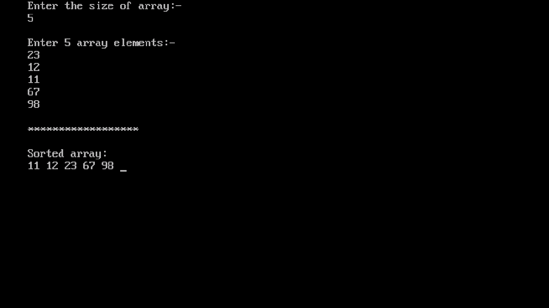

**Ques 16:- Program for Longest common subsequence .**

**Code :-**

#include<stdio.h>

#include<conio.h>

#include<stdlib.h>

#include<string.h>

int LCS();

int display(int, int);

int i, j, p, q;

char G[20], H[20], b[20][20], c[20][20];

void main()

{

clrscr();

printf("enter the first subsequence\n");

gets(G);

printf("enter the second subsequence\n");

gets(H);

printf("LCS is : ");

LCS();

display(p, q);

}

int LCS()

{

p = strlen(G);

q = strlen(H);

for(i=0;i<=p;i++)

{

c[i][0] = 0;

}

for(i=0;i<=q;i++)

{

c[0][i] = 0;

}

for(i=1;i<=p;i++)

{

for(j=1;j<=q;j++)

{

if(G[i-1] == H[j-1])

{

c[i][j] = c[i-1][j-1] + 1;

b[i][j] = 'c';

}

else if(c[i-1][j] >= c[i][j-1])

{

c[i][j] = c[i-1][j];

b[i][j] = 'u';

}

else

{

c[i][j] = c[i][j-1];

b[i][j] = 'l';

}

}

}

return 0;

}

int display(int i, int j)

{

if(i==0 || j==0)

{

return 0;

}

if(b[i][j] == 'c')

{

display(i-1, j-1);

printf("%c",G[i-1]);

}

else if(b[i][j] == 'u')

{

display(i-1, j);

}

else

{

display(i, j-1);

}

return 0;

}

**Output is:-**

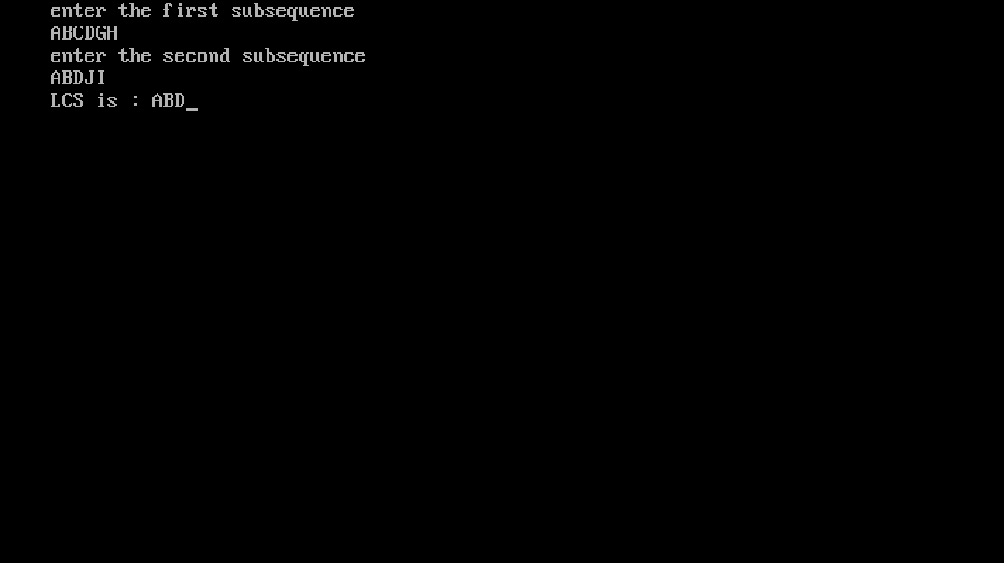

**Ques 17:- Program for Matrix chain multiplication .**

**Code :-**

#include <stdio.h>

#include <conio.h>

#include <limits.h>

#define INFY 999999999

long int m[20][20];

int s[20][20];

int p[20],i,j,n;

void print_optimal(int i,int j)

{

if (i == j)

printf(" A%d ",i);

else

{

printf("( ");

print_optimal(i, s[i][j]);

print_optimal(s[i][j] + 1, j);

printf(" )");

}

}

void matmultiply(void)

{

long int q;

int k;

for(i=n;i>0;i--)

{

for(j=i;j<=n;j++)

{

if(i==j) m[i][j]=0;

else

{

for(k=i;k<j;k++)

{

q=m[i][k]+m[k+1][j]+p[i-1]*p[k]*p[j];

if(q<m[i][j])

{

m[i][j]=q;

s[i][j]=k;

}

}

}

}

}

}

int MatrixChainOrder(int p[], int i, int j)

{

if(i == j)

return 0;

int k;

int min = INT_MAX;

int count;

for (k = i; k <j; k++)

{

count = MatrixChainOrder(p, i, k) + MatrixChainOrder(p, k+1, j) + p[i-1]*p[k]*p[j];

if (count < min) min = count;

}

return min;

}

void main()

{

clrscr();

int k;

printf("Enter the no. of elements: ");

scanf("%d",&n);

for(i=1;i<=n;i++)

for(j=i+1;j<=n;j++)

{

m[i][i]=0;

m[i][j]=INFY;

s[i][j]=0;

}

printf("\nEnter the dimensions: \n");

for(k=0;k<=n;k++)

{

printf("P%d: ",k);

scanf("%d",&p[k]);

}

matmultiply();

printf("\nCost Matrix M:\n");

for(i=1;i<=n;i++)

for(j=i;j<=n;j++)

printf("m[%d][%d]: %ld\n",i,j,m[i][j]);

i=1,j=n;

printf("\nMultiplication Sequence : ");

print_optimal(i,j);

printf("\nMinimum number of multiplications is : %d ", MatrixChainOrder(p, 1, n));

}

**Output is:-**

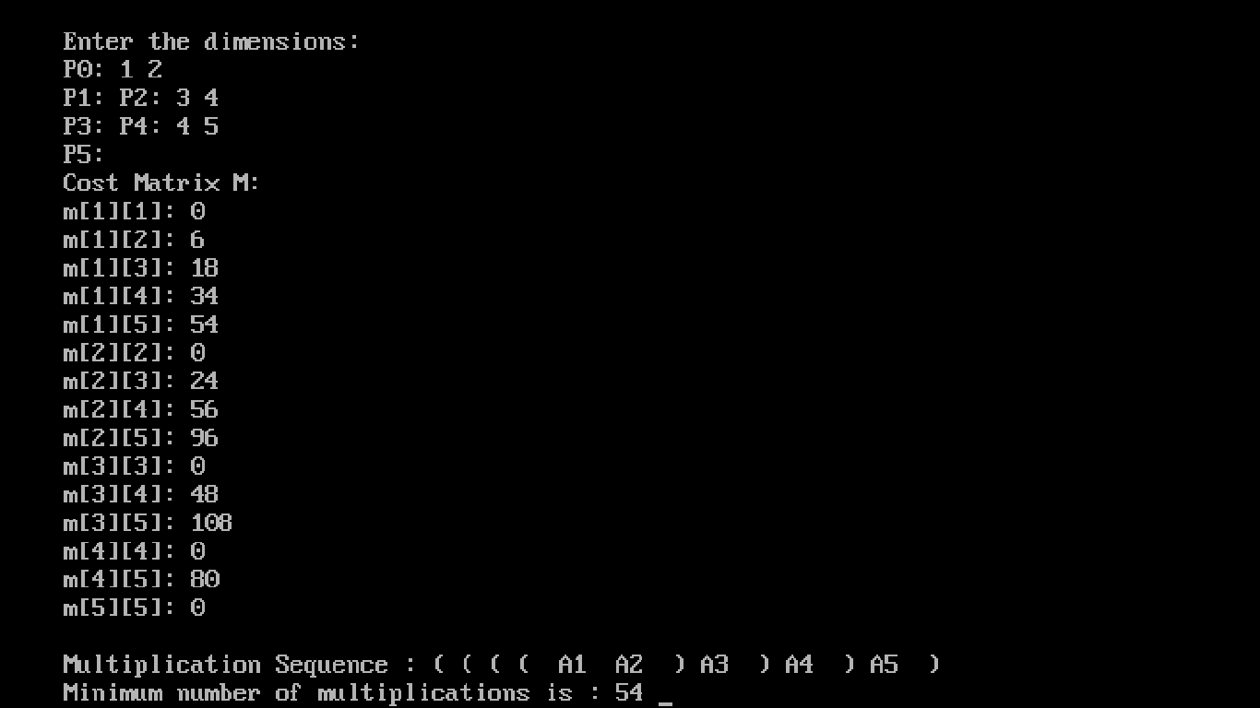

**Ques 18:- Program for Floyd Warshall all pair shortest path .**

**Code :-**

#include<stdio.h>

#include<conio.h>

int i, j, k,n,dist[10][10];

void floydWarshell ()

{

for (k = 0; k < n; k++)

for (i = 0; i < n; i++)

for (j = 0; j < n; j++)

if (dist[i][k] + dist[k][j] < dist[i][j])

dist[i][j] = dist[i][k] + dist[k][j];

}

int main()

{

clrscr();

int i,j;

printf("enter no of vertices :");

scanf("%d",&n);

printf("\n");

for(i=0;i<n;i++)

for(j=0;j<n;j++)

{

printf("dist[%d][%d]:",i,j);

scanf("%d",&dist[i][j]);

}

floydWarshell();

printf (" \n\n shortest distances between every pair of vertices \n");

for(i = 0; i < n; i++)

{

for(j = 0; j < n; j++)

printf ("%d\t", dist[i][j]);

printf("\n");

}

return 0;

}

**Output is :-**

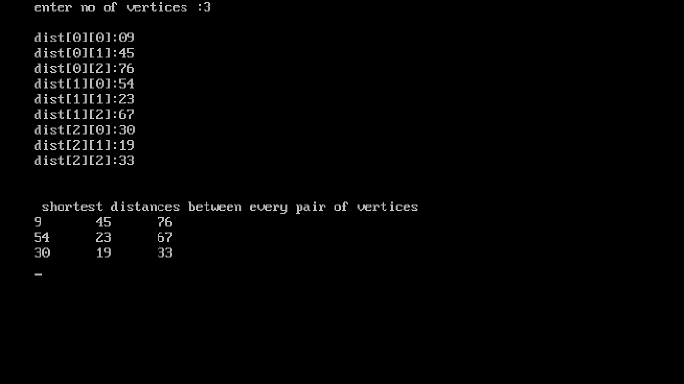

**Ques 19:- Program for strassean matrix multiplication .**

**Code :-**

#include<stdio.h>

#include<conio.h>

void main()

{

clrscr();

int a[2][2], b[2][2], c[2][2], i, j;

int m1, m2, m3, m4 , m5, m6, m7;

printf("Enter the 4 elements of first matrix: ");

for(i = 0;i < 2; i++)

for(j = 0;j < 2; j++)

scanf("%d", &a[i][j]);

printf("Enter the 4 elements of second matrix: ");

for(i = 0; i < 2; i++)

for(j = 0;j < 2; j++)

scanf("%d", &b[i][j]);

printf("\nThe first matrix is\n");

for(i = 0; i < 2; i++)

{

printf("\n");

for(j = 0; j < 2; j++)

printf("%d\t", a[i][j]);

}

printf("\nThe second matrix is\n");

for(i = 0;i < 2; i++)

{

printf("\n");

for(j = 0;j < 2; j++)

printf("%d\t", b[i][j]);

}

m1= (a[0][0] + a[1][1]) * (b[0][0] + b[1][1]);

m2= (a[1][0] + a[1][1]) * b[0][0];

m3= a[0][0] * (b[0][1] - b[1][1]);

m4= a[1][1] * (b[1][0] - b[0][0]);

m5= (a[0][0] + a[0][1]) * b[1][1];

m6= (a[1][0] - a[0][0]) * (b[0][0]+b[0][1]);

m7= (a[0][1] - a[1][1]) * (b[1][0]+b[1][1]); c[0][0] = m1 + m4- m5 + m7;

c[0][1] = m3 + m5;

c[1][0] = m2 + m4;

c[1][1] = m1 - m2 + m3 + m6;

printf("\nAfter multiplication using Strassen's algorithm \n");

for(i = 0; i < 2 ; i++)

{

printf("\n");

for(j = 0;j < 2; j++)

printf("%d\t", c[i][j]);

}

getch();

}

**Output is :-**

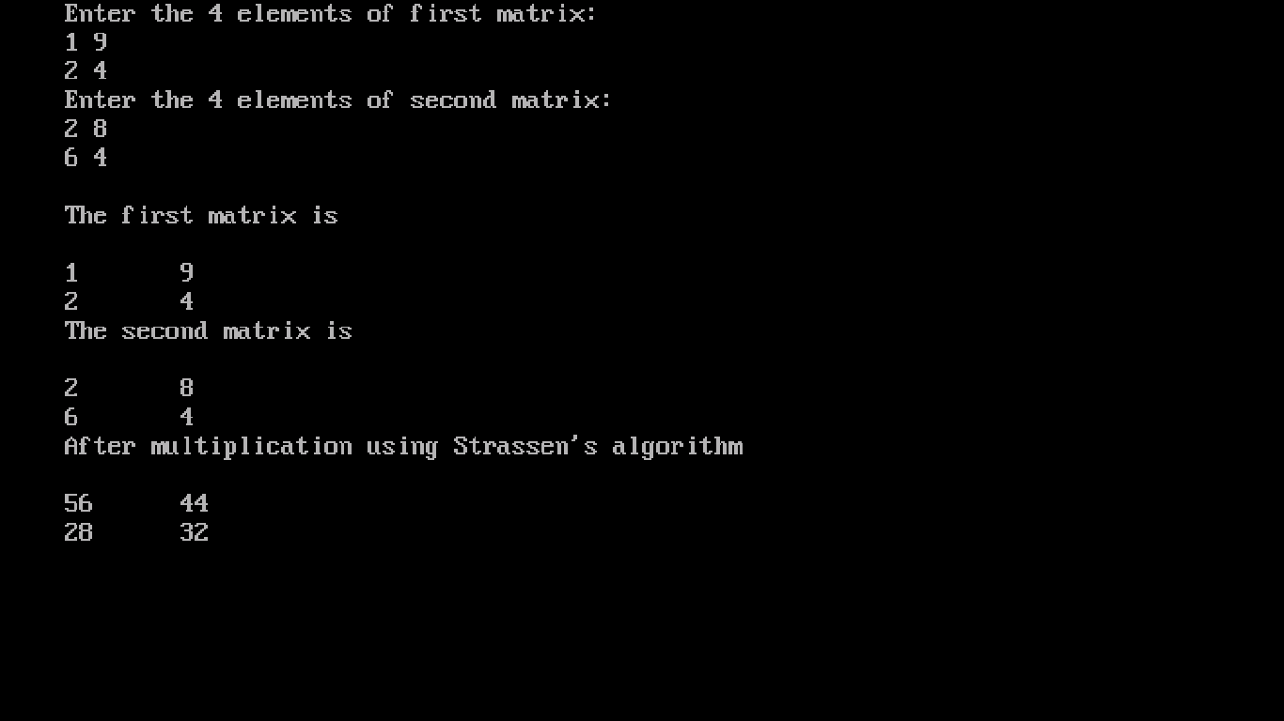

**Ques 20:- Program for Dijkstra algorithm .**

**Code :-**

#include<stdio.h>

#include<conio.h>

#define INFINITY 9999

#define MAX 10

void dijkstra(int G[MAX][MAX],int n,int startnode);

int main()

{

clrscr();

int G[MAX][MAX],i,j,n,u;

printf("Enter no. of vertices:");

scanf("%d",&n);

printf("\nEnter the adjacency matrix:\n");

for(i=0;i<n;i++)

for(j=0;j<n;j++)

scanf("%d",&G[i][j]);

printf("\nEnter the starting node:");

scanf("%d",&u);

dijkstra(G,n,u);

return 0;

}

void dijkstra(int G[MAX][MAX],int n,int startnode)

{

int cost[MAX][MAX],distance[MAX],pred[MAX];

int visited[MAX],count,mindistance,nextnode,i,j;

for(i=0;i<n;i++)

for(j=0;j<n;j++)

if(G[i][j]==0)

cost[i][j]=INFINITY;

else cost[i][j]=G[i][j];

for(i=0;i<n;i++)

{

distance[i]=cost[startnode][i];

pred[i]=startnode;

visited[i]=0;

}

distance[startnode]=0;

visited[startnode]=1;

count=1;

while(count<n-1)

{

mindistance=INFINITY;

for(i=0;i<n;i++)

if(distance[i]<mindistance&&!visited[i])

{

mindistance=distance[i];

nextnode=i;

}

visited[nextnode]=1;

for(i=0;i<n;i++)

if(!visited[i])

if(mindistance+cost[nextnode][i]<distance[i])

{

distance[i]=mindistance+cost[nextnode][i];

pred[i]=nextnode;

}

count++;

}

for(i=0;i<n;i++)

if(i!=startnode)

{

printf("\nDistance of node%d=%d",i,distance[i]);

printf("\nPath=%d",i);

j=i;

do

{

j=pred[j];

printf("<-%d",j);

}

while(j!=startnode);

}

}

**Output is :-**

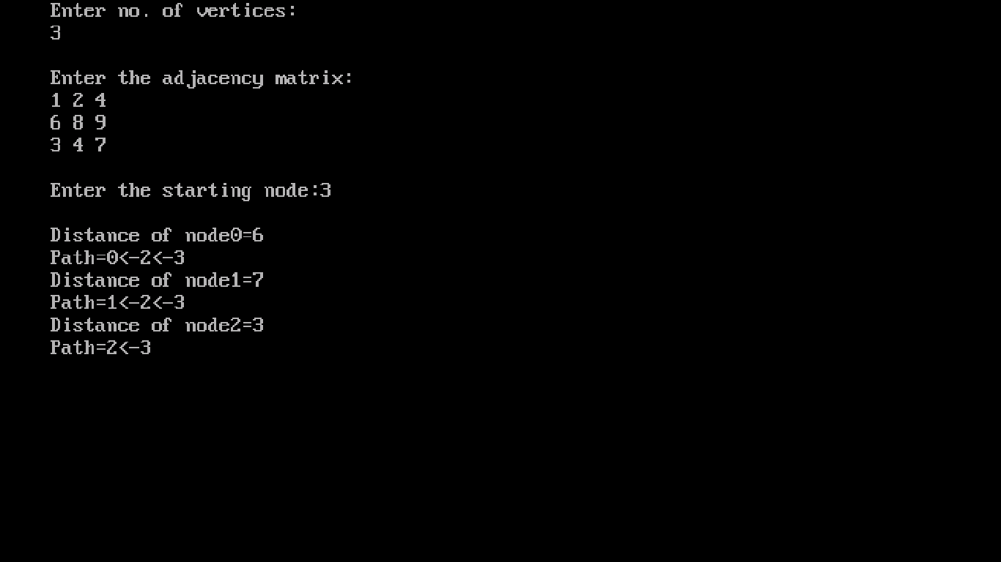

**Ques 21:- Program for0/1 knapsack problem by dynamic programming.**

**Code :-**

#include<stdio.h>

#include<conio.h>

#define MAX 100

int main()

{

int n,flag[MAX]={0},v[MAX],w[MAX],m[MAX][MAX],W,i,j,k;

clrscr();

printf("Enter the number of elements: ");

scanf("%d",&n);

printf("Enter the values: ");

for(i=1;i<=n;i++)

scanf("%d",&v[i]);

printf("Enter the weights: ");

for(i=1;i<=n;i++)

scanf("%d",&w[i]);

printf("Enter the capacity of knapsack: ");

scanf("%d",&W);

for(j=0;j<=W;j++)

m[0][j]=0;

for(i=1;i<=n;i++)

{

for(j=0;j<=W;j++)

{

if(w[i]<=j)

{

if( m[i-1][j] > (m[i-1][j-w[i]]+v[i]) )

m[i][j]=m[i-1][j];

else

m[i][j]=m[i-1][j-w[i]]+v[i];

}

else

m[i][j]=m[i-1][j];

}

}

i=n;

k=W;

while(i>0 && k>0)

{

if(m[i][k]!=m[i-1][k])

{

flag[i]=1;

k=k-w[i];

i=i-1;

}

else

i--;

}

printf("\n\t");

for(i=0;i<=W;i++)

printf("%d\t",i);

printf("\n");

for(i=0;i<=10*W;i++)

printf("-");

printf("\n");

for(i=0;i<=n;i++)

{

printf("%d |\t", i); //to print the vertical line

for(j=0;j<=W;j++)

printf("%d\t",m[i][j]);

printf("\n");

}

printf("\nThe resultant vector is ");

printf("( ");

for(i=1;i<=n;i++)

printf("%d ",flag[i]);

printf(")");

printf("\n\nThe total profit is %d",m[n][W]);

printf("\n");

getch();

return 0;

}

**Output is :-**

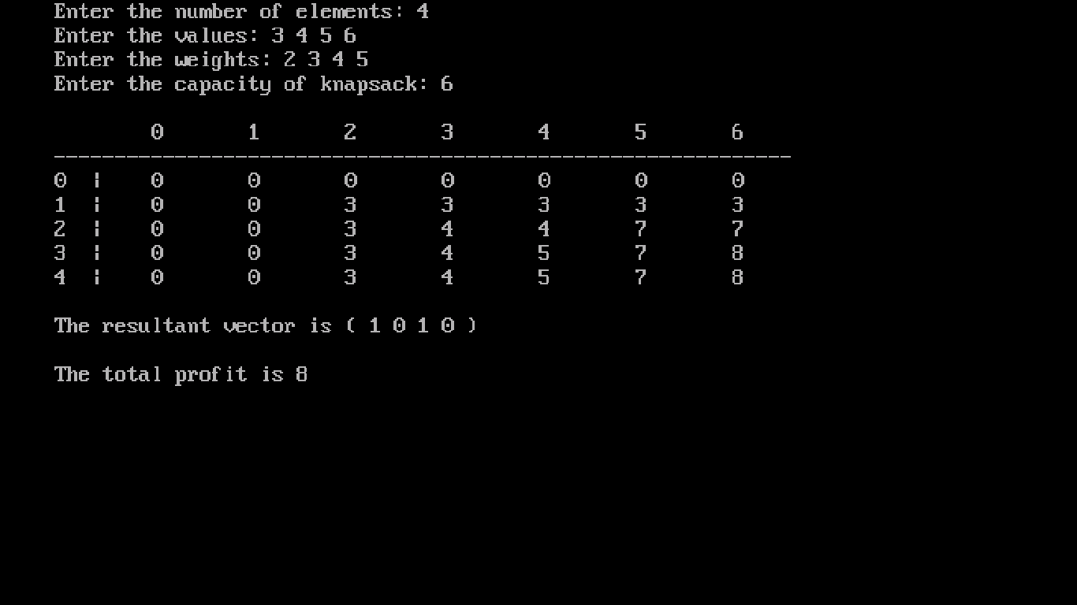

**Ques 22:- Program for Graph Traversal using BFS .**

**Code :-**

#include<stdio.h>

#include<conio.h>

int a[20][20], q[20], visited[20], n, i, j, f = 0, r = -1;

void bfs(int v)

{

for(i = 1; i <= n; i++)

if(a[v][i] && !visited[i])

q[++r] = i;

if(f <= r)

{

visited[q[f]] = 1;

bfs(q[f++]);

}

}

void main()

{

clrscr();

int v;

printf("\n Enter the number of vertices:");

scanf("%d", &n);

for(i=1; i <= n; i++)

{

q[i] = 0;

visited[i] = 0;

}

printf("\n Enter graph data in matrix form:\n");

for(i=1; i<=n; i++)

{

for(j=1;j<=n;j++)

{

scanf("%d", &a[i][j]);

}

}

printf("\n Enter the starting vertex:");

scanf("%d", &v);

bfs(v);

printf("\n The node which are reachable are:\n");

for(i=1; i <= n; i++)

{

if(visited[i])

printf("%d\t", i);

else

{

printf("\n Bfs is not possible. Not all nodesare not reachable");

break;

}

}

}

**Output is :-**

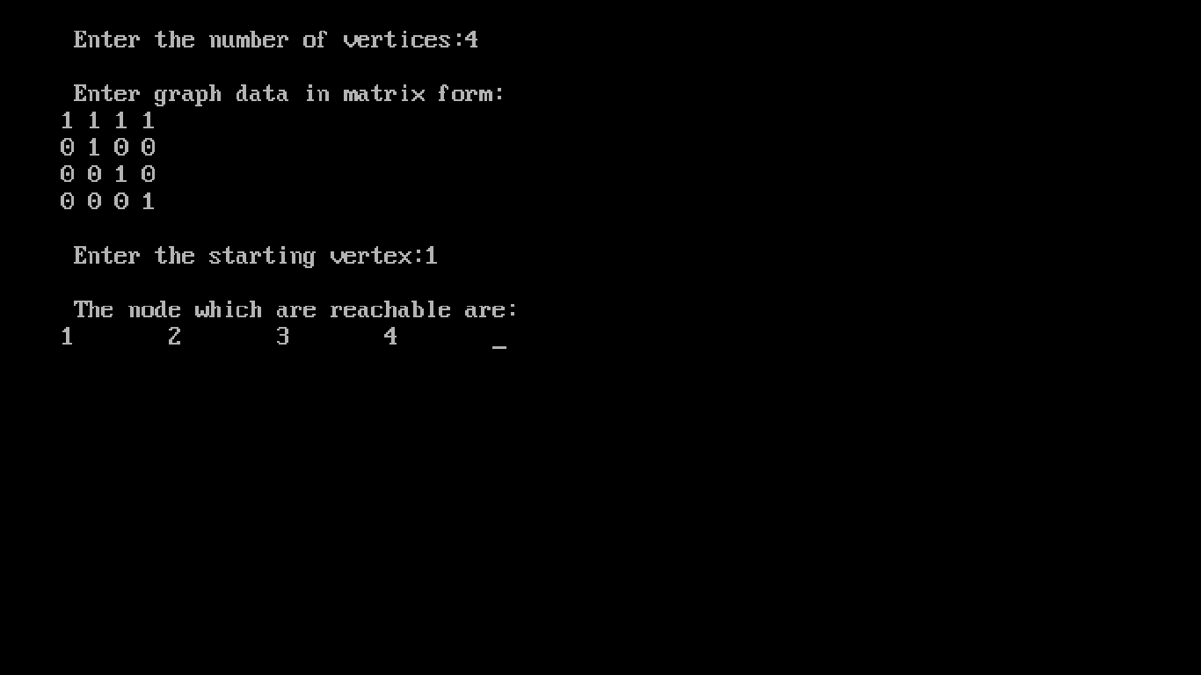

**Ques 23:- Program for Graph Traversal using DFS .**

**Code :-**

#include<stdio.h>

#include<conio.h>

int a[20][20],reach[20],n;

void dfs(int v)

{

int i;

reach[v]=1;

for (i=1;i<=n;i++)

if(a[v][i] && !reach[i])

{

printf("\n %d->%d",v,i);

dfs(i);

}

}

void main()

{

int i,j,count=0;

clrscr();

printf("\n Enter number of vertices:");

scanf("%d",&n);

for (i=1;i<=n;i++)

{

reach[i]=0;

for (j=1;j<=n;j++)

a[i][j]=0;

}

printf("\n Enter the adjacency matrix:\n");

for (i=1;i<=n;i++)

for (j=1;j<=n;j++)

scanf("%d",&a[i][j]);

dfs(1);

printf("\n");

for (i=1;i<=n;i++)

{

if(reach[i])

count++;

}

if(count==n)

printf("\n Graph is connected");

else

printf("\n Graph is not connected");

getch();

}

**Output is :-**

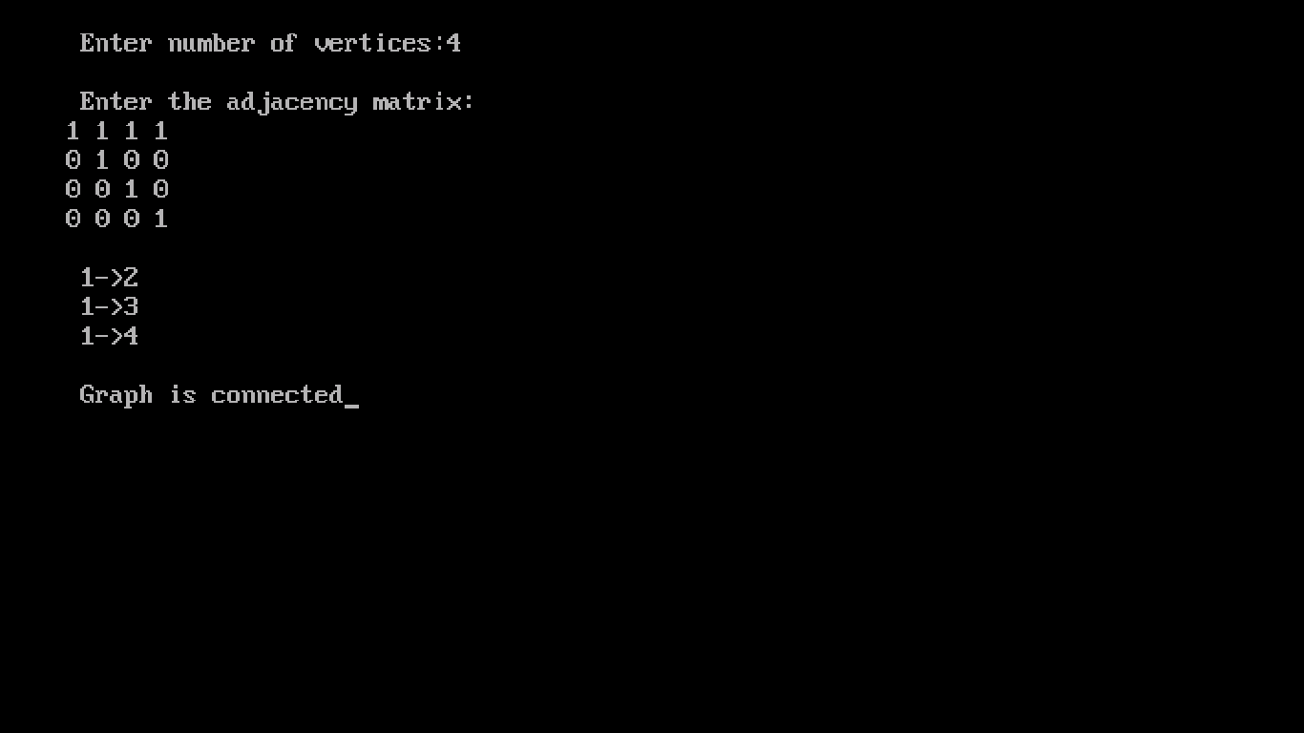

**Ques 24:- Program for N Queen’s Problem .**

**Code :-**

#include<stdio.h>

#include<conio.h>

#include<stdlib.h>

int t[5] = {-1};

int sol = 1;

void printsol()

{

int i,j;

char crossboard[5][5];

for(i=0;i<5;i++)

{

for(j=0;j<5;j++)

{

crossboard[i][j]='_';

}

}

for(i=0;i<5;i++)

{

crossboard[i][t[i]]='q';

}

for(i=0;i<5;i++)

{

for(j=0;j<5;j++)

{

printf("%c ",crossboard[i][j]);

}

printf("\n");

}

}

int empty(int i)

{

int j=0;

while((t[i]!=t[j])&&(abs(t[i]-t[j])!=(i-j))&&j<5)j++;

return i==j?1:0;

}

void queens(int i)

{

for(t[i] = 0;t[i]<5;t[i]++)

{

if(empty(i))

{

if(i==4)

{

printsol();

printf("\n solution %d\n",sol++);

}

else queens(i+1);

}

}

}

int main()

{

clrscr();

queens(0);

printf("\n Total Number of Solutions is %d",sol);

return 0;

}

**Output is :-**

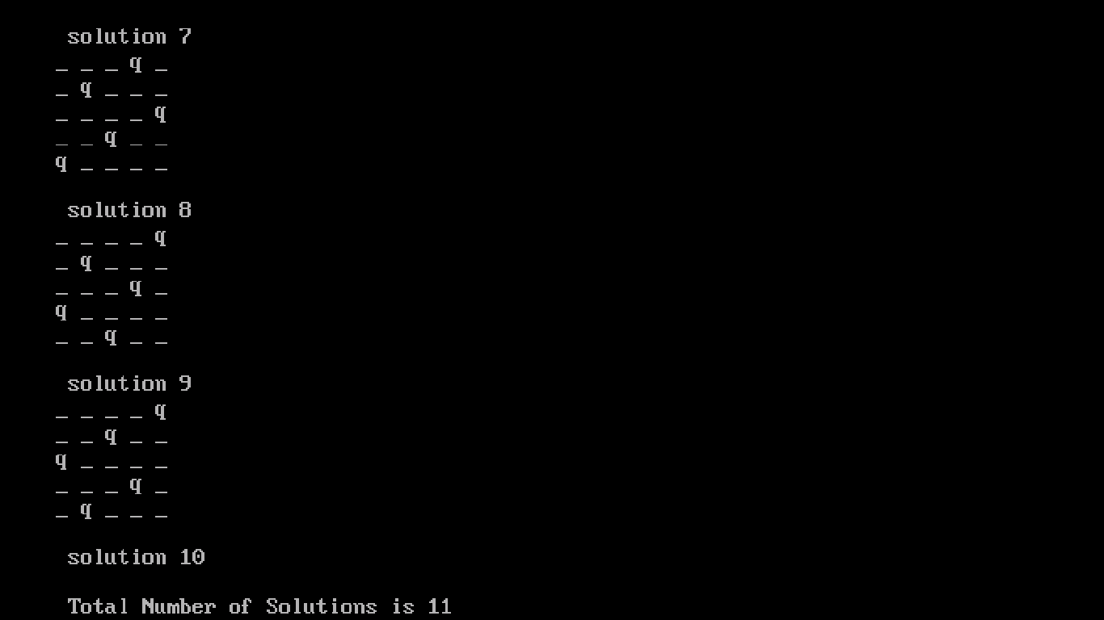

**Ques 25:- Program for MST using prim’s algorithm .**

**Code :-**

#include<stdio.h>

#include<conio.h>

#include<stdlib.h>

#define infinity 9999

#define MAX 20

int G[MAX][MAX],spanning[MAX][MAX],n;

int prims();

int main()

{

clrscr();

int i,j,total_cost;

printf("\nImplementation of Prims Algorithm:-\n");

printf("\nEnter no. of vertices:");

scanf("%d",&n);

printf("\nEnter the adjacency matrix:\n");

for(i=0;i<n;i++)

for(j=0;j<n;j++)

scanf("%d",&G[i][j]);

total_cost=prims();

printf("\nspanning tree matrix:\n");

for(i=0;i<n;i++)

{

printf("\n");

for(j=0;j<n;j++)

printf("%d\t",spanning[i][j]);

}

printf("\n\nTotal cost of spanning tree=%d",total_cost);

return 0;

}

int prims()

{

int cost[MAX][MAX];

int u,v,min_distance,distance[MAX],from[MAX];

int visited[MAX],no_of_edges,i,min_cost,j;

for(i=0;i<n;i++)

for(j=0;j<n;j++)

{

if(G[i][j]==0)

cost[i][j]=infinity;

else

cost[i][j]=G[i][j];

spanning[i][j]=0;

}

distance[0]=0;

visited[0]=1;

for(i=1;i<n;i++)

{

distance[i]=cost[0][i];

from[i]=0;

visited[i]=0;

}

min_cost=0;

no_of_edges=n-1;

while(no_of_edges>0)

{

min_distance=infinity;

for(i=1;i<n;i++)

if(visited[i]==0&&distance[i]<min_distance)

{

v=i;

min_distance=distance[i];

}

u=from[v];

spanning[u][v]=distance[v];

spanning[v][u]=distance[v];

no_of_edges--;

visited[v]=1;

for(i=1;i<n;i++)

if(visited[i]==0&&cost[i][v]<distance[i])

{

distance[i]=cost[i][v];

from[i]=v;

}

min_cost=min_cost+cost[u][v];

}

return(min_cost);

}

**Output is :-**

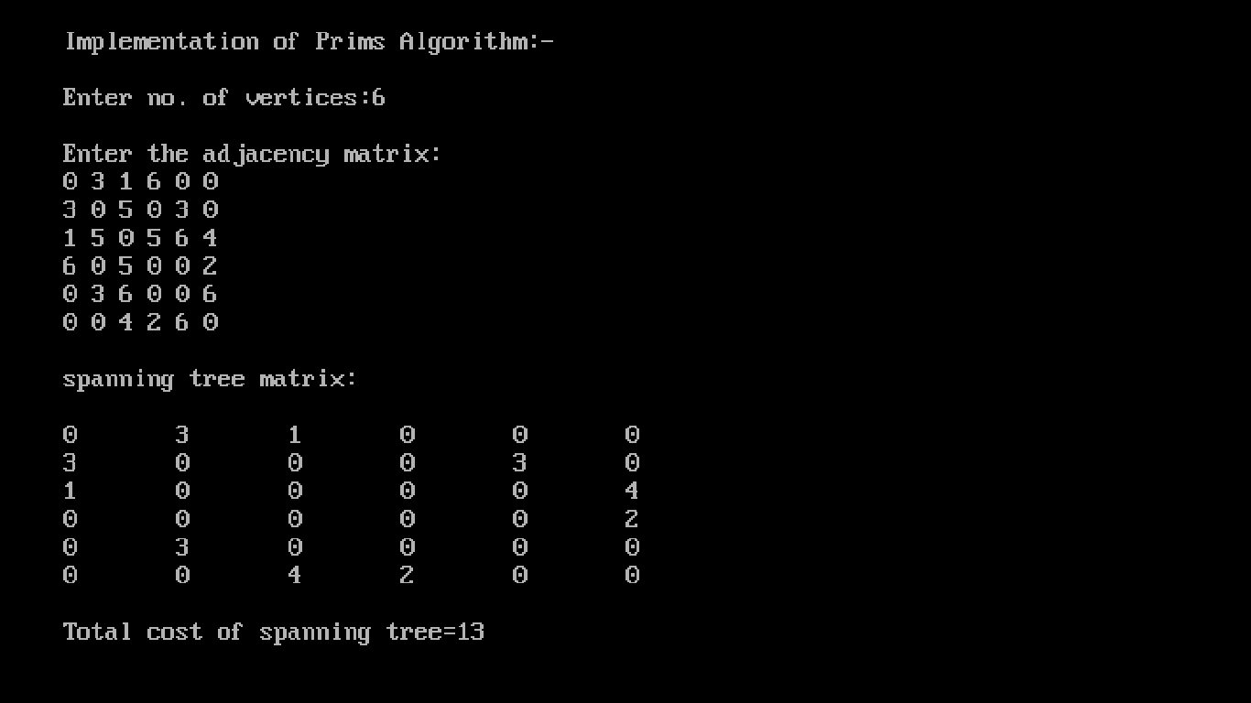

**Ques 26:- Program for MST using kruskal algorithm.**

**Code :-**

#include<stdio.h>

#include<conio.h>

#include<stdlib.h>

int i,j,k,a,b,u,v,n,ne=1;

int min,mincost=0,cost[9][9],parent[9];

int find(int);

int uni(int,int);

void main()

{

clrscr();

printf("\nImplementation of Kruskal's algorithm:-\n");

printf("\nEnter the no. of vertices:-");

scanf("%d",&n);

printf("\nEnter the cost adjacency matrix:-\n");

for(i=1;i<=n;i++)

{

for(j=1;j<=n;j++)

{

scanf("%d",&cost[i][j]);

if(cost[i][j]==0)

cost[i][j]=999;

}

}

printf("The edges of Minimum Cost Spanning Tree are:-\n");

while(ne < n)

{

for(i=1,min=999;i<=n;i++)

{

for(j=1;j <= n;j++)

{

if(cost[i][j] < min)

{

min=cost[i][j];

a=u=i;

b=v=j;

}

}

}

u=find(u);

v=find(v);

if(uni(u,v))

{

printf("%d edge (%d,%d) =%d\n",ne++,a,b,min);

mincost +=min;

}

cost[a][b]=cost[b][a]=999;

}

printf("\nMinimum cost:- = %d\n",mincost);

getch();

}

int find(int i)

{

while(parent[i])

i=parent[i];

return i;

}

int uni(int i,int j)

{

if(i!=j)

{

parent[j]=i;

return 1;

}

return 0;

}

**Output is :-**

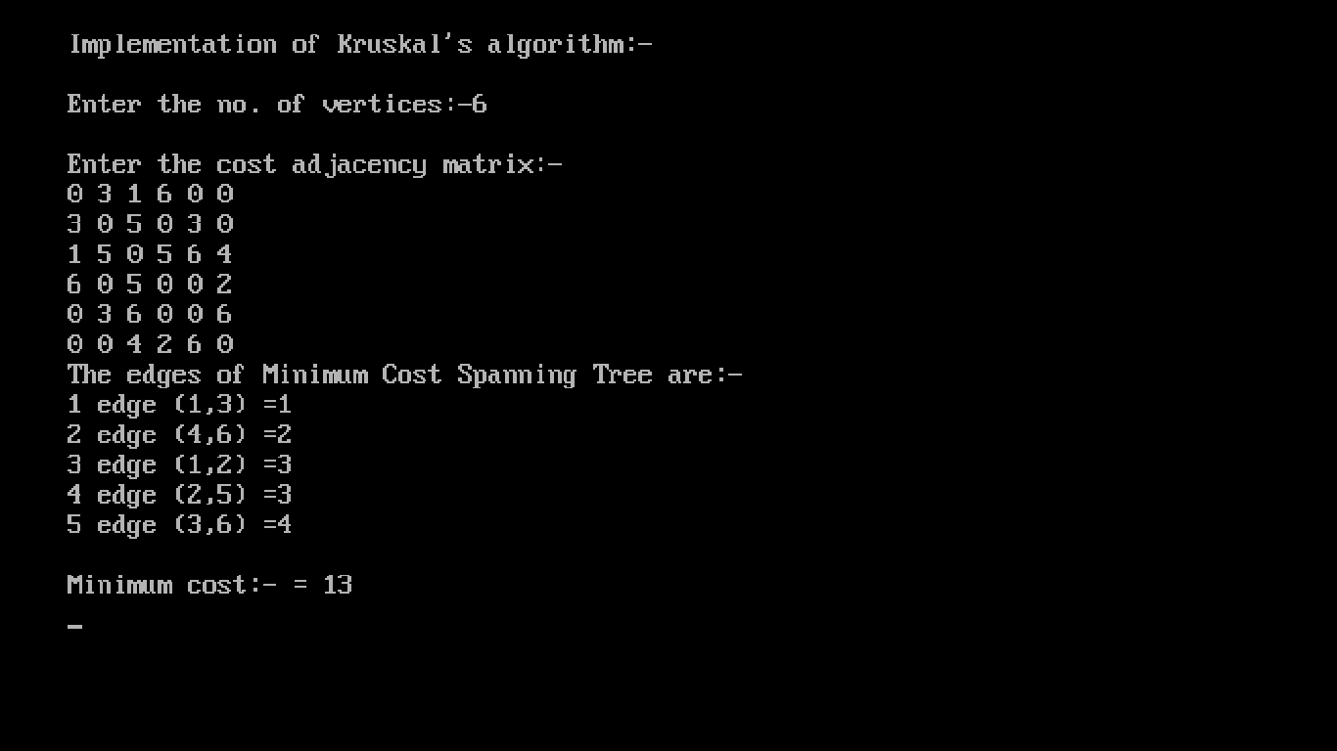

**Ques 27 :- Program for Sum of subset problem.**

**Code :-**

#include <stdio.h>

bool isSubsetSum(int set[], int n, int sum)

{

if (sum == 0)

return true;

if (n == 0)

return false;

if (set[n - 1] > sum)

return isSubsetSum(set, n - 1, sum);

return isSubsetSum(set, n - 1, sum)

|| isSubsetSum(set, n - 1, sum - set[n - 1]);

}

int main()

{

int set[] = { 3, 34, 4, 12, 5, 2 };

int sum = 9;

int n = sizeof(set) / sizeof(set[0]);

if (isSubsetSum(set, n, sum) == true)

printf("\n\n\n\n Found a subset with given sum\n\n\n\n");

else

printf("\n No subset with given sum");

return 0;

}

**Output is :-**

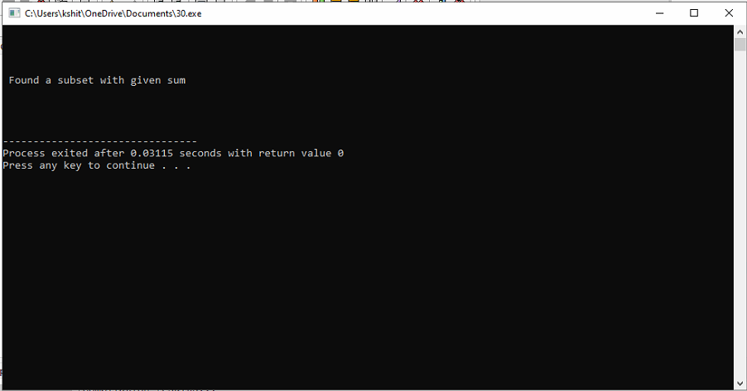

**Ques 28 :- Program for Graph coloring problem.**

**Code :-**

#include<stdio.h>

#include<conio.h>

int G[50][50],x[50];

void next_color(int k)

{

int i,j;

x[k]=1;

for(i=0;i<k;i++)

{

if(G[i][k]!=0 && x[k]==x[i])

x[k]=x[i]+1;

}

}

void main()

{

clrscr();

int n,a,i,j,k,l;

printf("\n Enter no. of vertices :- ");

scanf("%d",&n);

printf("\n Enter no. of edges :- ");

scanf("%d",&a);

for(i=0;i<n;i++)

for(j=0;j<n;j++)

G[i][j]=0;

printf("\n Enter indexes where value is 1:- \n");

for(i=0;i<a;i++)

{

scanf("%d %d",&k,&l);

G[k][l]=1;

G[l][k]=1;

}

for(i=0;i<n;i++)

next_color(i);

printf("\n Colors of vertices :-\n");

for(i=0;i<n;i++)

printf("Vertex[%d] : %d\n",i+1,x[i]);

getch();

}

**Output is :-**

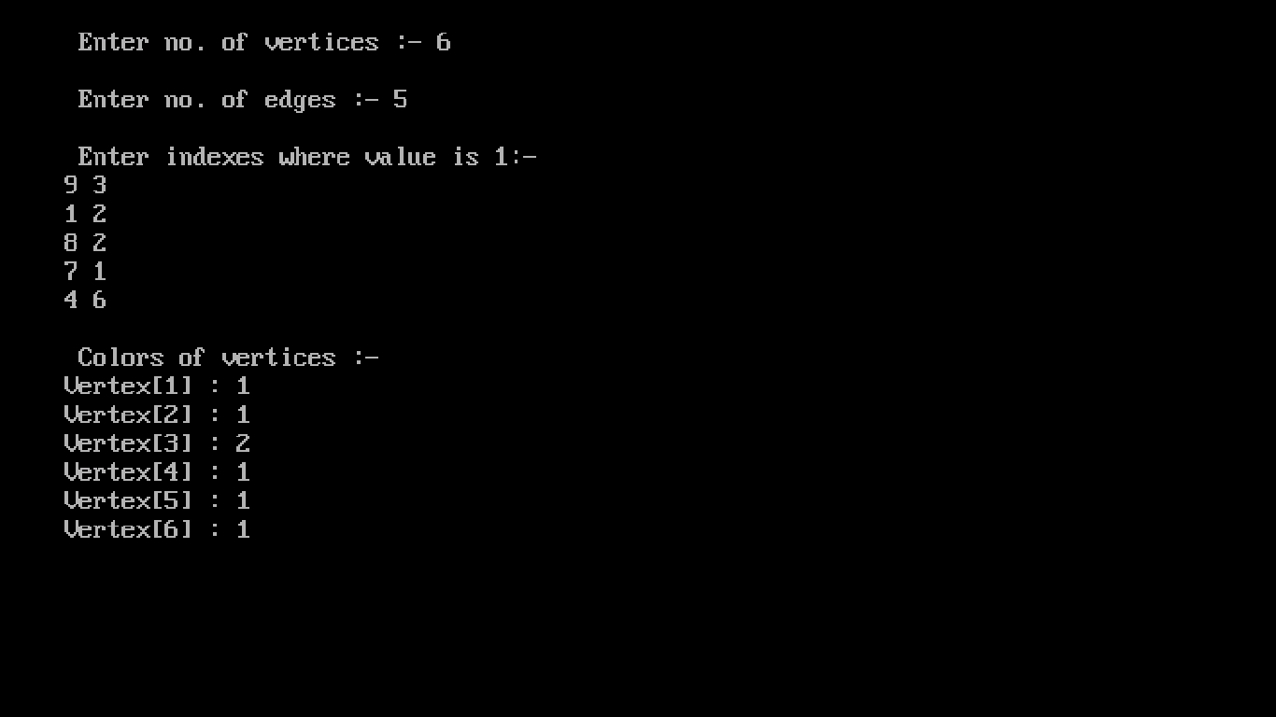

**Ques 29 :- Program for Job scheduling with deadline problem.**

**Code :-**

#include <stdio.h>

#include <conio.h>

#define MAX 100

typedef struct Job

{

char id[5];

int deadline;

int profit;

}

Job;

void jobSequencingWithDeadline(Job jobs[], int n);

int minValue(int x, int y) {

if(x < y) return x;

return y;

}

int main(void) {

clrscr();

int i, j;

Job jobs[5] = {

{"j1", 2, 200},

{"j2", 1, 100},

{"j3", 3, 120},

{"j4", 1, 240},

{"j5", 1, 20},

};

Job temp;

int n = 5;

for(i = 1; i < n; i++) {

for(j = 0; j < n - i; j++) {

if(jobs[j+1].profit > jobs[j].profit) {

temp = jobs[j+1];

jobs[j+1] = jobs[j];

jobs[j] = temp;

}

}

}

printf("%10s %10s %10s\n", "Job", "Deadline", "Profit");

for(i = 0; i < n; i++)

{

printf("%10s %10i %10i\n", jobs[i].id, jobs[i].deadline, jobs[i].profit);

}

jobSequencingWithDeadline(jobs, n);

return 0;

}

void jobSequencingWithDeadline(Job jobs[], int n) {

int i, j, k, maxprofit;

int timeslot[MAX];

int filledTimeSlot = 0;

int dmax = 0;

for(i = 0; i < n; i++) {

if(jobs[i].deadline > dmax) {

dmax = jobs[i].deadline;

}

}

for(i = 1; i <= dmax; i++)

{

timeslot[i] = -1;

}

printf("dmax: %d\n", dmax);

for(i = 1; i <= n; i++)

{

k = minValue(dmax, jobs[i - 1].deadline);

while(k >= 1)

{

if(timeslot[k] == -1)

{

timeslot[k] = i-1;

filledTimeSlot++;

break;

}

k--;

}

if(filledTimeSlot == dmax) {

break;

}

}

printf("\nRequired Jobs: ");

for(i = 1; i <= dmax; i++) {

printf("%s", jobs[timeslot[i]].id);

if(i < dmax) {

printf(" --> ");

}

}

maxprofit = 0;

for(i = 1; i <= dmax; i++)

{

maxprofit += jobs[timeslot[i]].profit;

}

printf("\nMax Profit: %d\n", maxprofit);

}

**Output is :-**

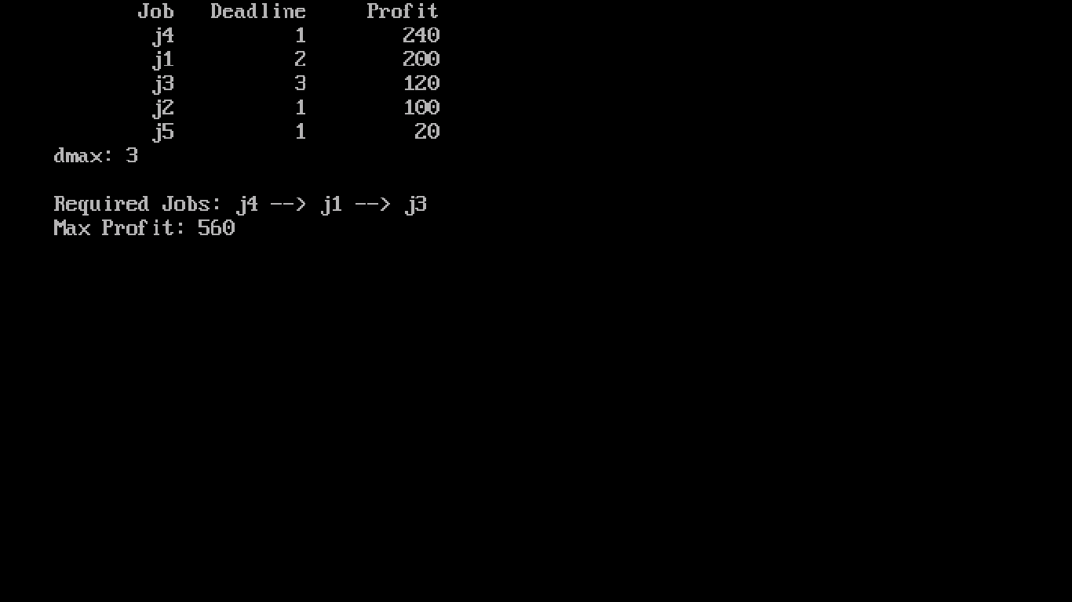

**Ques 30 :- Program for Vertex cover problem using approximation algorithm.**

**Code :-**

#include<iostream>

#include <list>

using namespace std;

class Graph

{

int V;

list<int> *adj;

public:

Graph(int V);

void addEdge(int v, int w);

void printVertexCover();

};

Graph::Graph(int V)

{

this->V = V;

adj = new list<int>[V];

}

void Graph::addEdge(int v, int w)

{

adj[v].push_back(w);

adj[w].push_back(v);

}

void Graph::printVertexCover()

{

bool visited[V];

for (int i=0; i<V; i++)

visited[i] = false;

list<int>::iterator i;

for (int u=0; u<V; u++)

{

if (visited[u] == false)

{

for (i= adj[u].begin(); i != adj[u].end(); ++i)

{

int v = *i;

if (visited[v] == false)

{

visited[v] = true;

visited[u] = true;

break;

}

}

}

}

for (int i=0; i<V; i++)

if (visited[i])

cout << i << " ";

}

int main()

{

cout << "\n vertexes are:-\n "<< endl;

Graph g(7);

g.addEdge(5, 1);

g.addEdge(0, 2);

g.addEdge(1, 5);

g.addEdge(1, 7);

g.addEdge(4, 5);

g.addEdge(4, 9);

g.printVertexCover();

return 0;

}

**Output is :-**

